# Where should I open a restaurant at Polish seaside?

# 1. Introduction

### 1.1 Background

Over past years polish seaside towns have significantly developed in terms of holiday housing for rent or summer appartments. This trend on housing market has been followed by development of local venues. It is however not clear now if the market is already saturated and many entrepreneurs will wonder which are the best resorts to invest in, if one wants to open a restaurant. It may also not be clear if a particular type of cuisine is popular and there's still opportunity to open new venues of that type with positive return on investment.

Recent restrictions on restaurants and public places imposed due to virus threat also point to additional challanges in this industry, which should be considered in terms of business model. A company needs to have more resiliant offer, which would allow it to survive in times of crisis like this. A well rounded and diversified offer towards the public is preferred, over a standard fish&chips van. Reading through available research and publications is a must for entrepreneurs to make sure they exhaust information sources to guide their investment decisions.

This report could also be treated as an objective context or argument when entrepreneurs try to get external funding for launch of their business in these extraordinary times. Beyond entrepreneurs, the content of this project will be valuable to capital funds, venture capitalists or business angels, who invest private money into businesses. It will present and assess overall potential of polish seaside resorts based on objective, data-based criteria for Italian restaurants.

### 1.2 Problem

In this report, I will narrow down the problem to answer the following question: where should an entrepreneur open an Italian cuisine restaurant, considering Polish seaside resorts. Among factors I intend to consider will be number of restaurants, their cuisine type, their geospatial distribution in selected towns. Working assumption is that a place which is good to open a new restaurant does not have a neighboring restaurant of the same cuisine type in range of 15km. It should however be in a "food-serving" zone of the town so it's easily accessible to people. If there is no other Italian restaurant in certain town, this town should be considered a 'golden spot' location.

# 2. Data acquisition and cleaning

### 2.1. Data sources

**2.1.2. Location data**

I will use foursquare data (<https://foursquare.com/>) to get information about seaside resorts in Poland. Foursquare has plenty of data points about places, globally - 65M+ from 190 Countries. 900 Venue categories - including restaurants and cuisine type, including 'Italian restaurant' which will be of interest for this project (<https://developer.foursquare.com/docs/build-with-foursquare/categories/>). 30+ attributes for each of those venues, where most important here will be venue name, address, ratings, and reviews. Among others, it's possible in this data set to check visits to selected locations, which would be relevant when deciding about location of a new restaurant. Foursquare enables identification of popular and trending location, which I will also include.

**2.1.3. Municipalities - administrative split**

I will preselect the places to include into my comparative analysis, as I am only interested in major seaside resorts. To ensure the analysis is useful to wide spectrum of audience I will include all municipalities which are directly by the sea and in western Poland. The list will be compiled from here: <https://upload.wikimedia.org/wikipedia/commons/f/f9/Zachodniopomorskie_powiaty_2005.svg>. The following towns will be included:

1. Świnoujście,
2. Międzyzrdoje,
3. Dziwnów,
4. Rewal,
5. Kołobrzeg,
6. Ustronie Morskie,
7. Mielno,
8. Darłowo,

### 2.2. Data cleaning

As part of standard pre-checks I performed couple of manipulations on the output data as needed.

Firstly, extracted and renamed the columns to be more informative. Secondly, finding and replacing null values of a city. I took a nearest neighbor approach, so within a specified range of 15 km the null value was replaced with name of the central town.

As a result for each town on the western coast I got a table similar to the one below.

Table before filling null values:

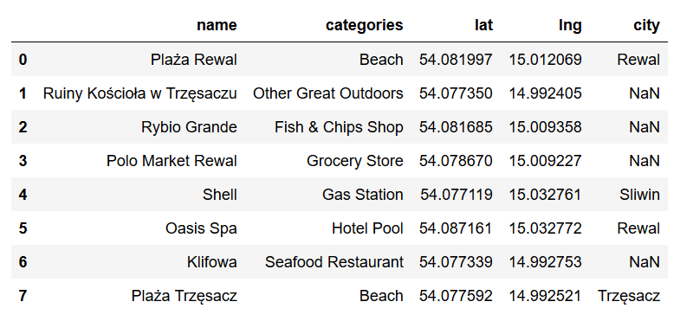

Table after filling null values:

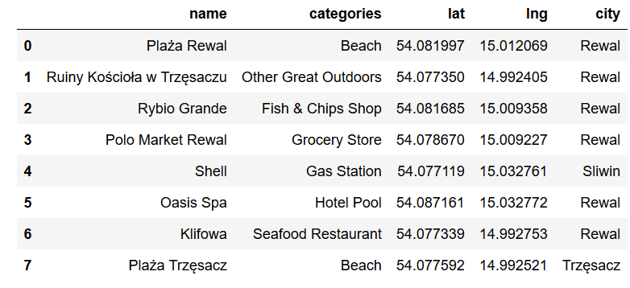

I also noticed that some restaurants are classified as Italian restaurants automatically, while pizza-places were not considered restaurants but rather fast-food place. I consciously did not interviene, to keep data consistent and differentiate between an Italian-cuisine restaurant and just a fastfood selling pizzas, which may or may not be even based on Italian recipes.

# 3. Methodology and Exploratory Data Analysis

### 3.1. Summary of italian restaurants per resort

In the next steps I filtered the Italian restaurants in each resort and received the following results

Świnoujście:

Empty DataFrame

Międzyzrdoje:

Dolce Vita Ristorante Italiana Italian Restaurant 53.929005 14.450672 city Międzyzdroje

Dziwnów:

Empty DataFrame

Rewal:

Empty DataFrame

Kołobrzeg:

name categories lat lng city

Restauracja Portowa Italian Restaurant 54.186564 15.555855 Kołobrzeg

Ustronie Morskie:

Empty DataFrame

Mielno:

Empty DataFrame

Darłowo:

Empty DataFrame

### 3.2. Mapping of all venues for towns without Italian cuisine restaurants

Later on I mapped each of the towns without an Italian restaurant and their venues on the map, to see their distribution.

Świnoujście

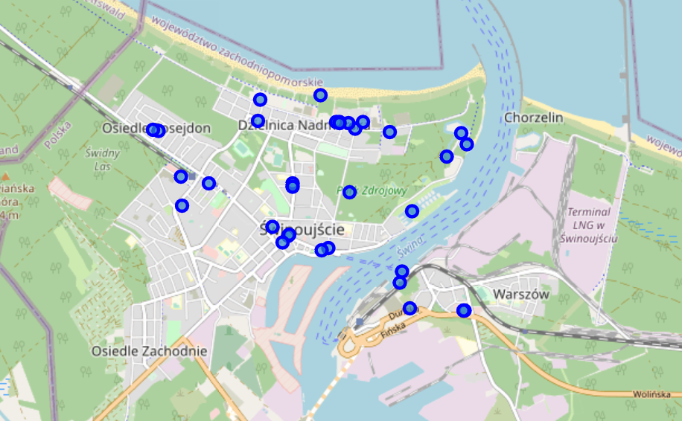

Dziwnów

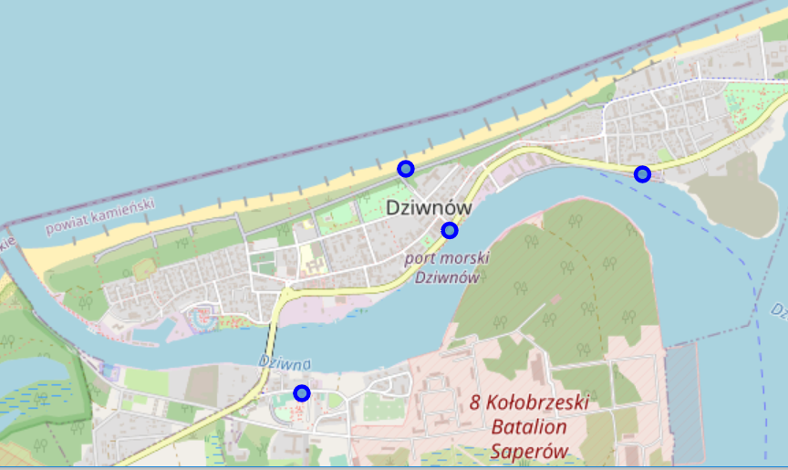

Rewal

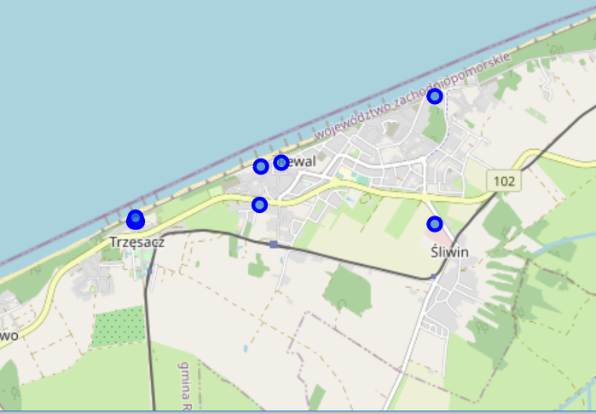

Ustronie Morskie

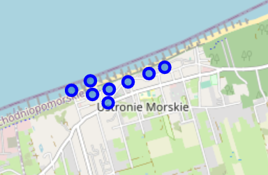

Mielno

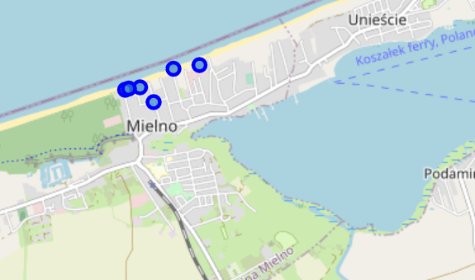

Darłowo

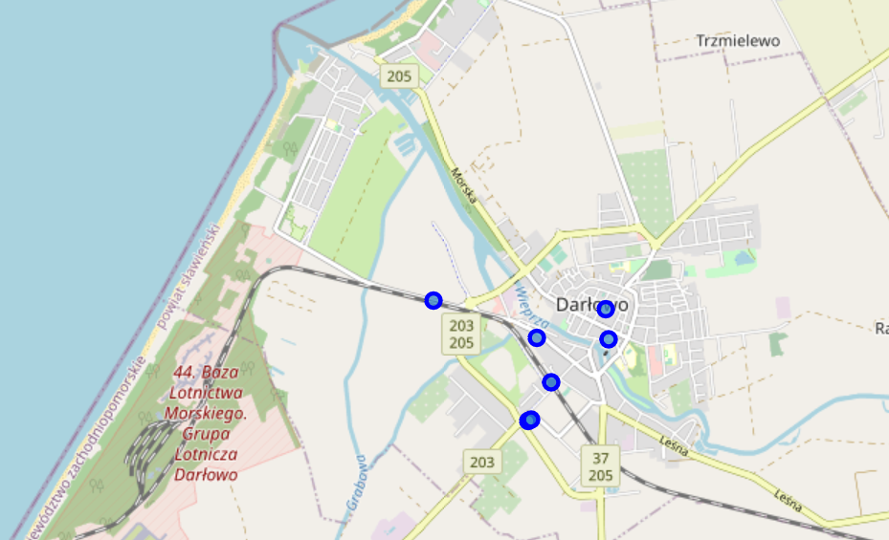

# 4. Results and discussion

It is a surprise that only 2 out of the 8 towns have an Italian restaurant. It means there’s still great potential to open a restaurant of this cuisine type in a couple of western seaside resorts.

When thinking where to locate an Italian restaurant one needs to think about, among other things:

* number of nearby restaurants,
* their cuisine type/profile,
* their geospatial distribution in selected towns

Features of a place which is good to open a new restaurant:

* does not have a neighboring restaurant of the same cuisine type in range of 15km.
* it should be in a "food-serving" zone of the town so it's easily accessible to people.
* If an Italian restaurant in certain town doesn’t exist, this town should be considered a 'golden spot' location

Let’s see what is the restaurant situation in each of the 6 resorts which have the potential.

Świnoujście:

name categories lat \

4 Magiczna Spiżarnia Polish Restaurant 53.907843

5 Neptun Eastern European Restaurant 53.909136

7 Amsterdam Café Restaurant 53.919272

8 Mila Restaurant 53.919168

13 Kurna Chata Restaurant 53.913785

21 Karczma Polska Pod Kogutem Eastern European Restaurant 53.921285

23 McDonald's Fast Food Restaurant 53.914396

24 Dunes Seafood Restaurant 53.919236

Międzyzrdoje:

name categories lat lng \

0 Tawerna Róża Wiatrów Restaurant 53.928670 14.450467

8 Nemo Bistro&Pub Seafood Restaurant 53.931478 14.447263

10 Dolce Vita Ristorante Italiana Italian Restaurant 53.929005 14.450672

Dziwnów:

Empty DataFrame

Rewal:

name categories lat lng city

6 Klifowa Seafood Restaurant 54.077339 14.992753 Rewal

Kołobrzeg:

name categories lat lng \

0 Domek Kata Eastern European Restaurant 54.176595 15.576488

3 Pirania 2 Seafood Restaurant 54.184779 15.565897

7 NAKAMAL BAR & GRILL Restaurant 54.184355 15.556195

10 Rewiński Seafood Restaurant 54.186608 15.555298

12 Pod Winogronami Restaurant 54.184443 15.555789

14 McDonald's Fast Food Restaurant 54.176186 15.595794

19 Restauracja Portowa Italian Restaurant 54.186564 15.555855

21 Pergola Seafood Restaurant 54.186585 15.556242

26 Ale Ryba Seafood Restaurant 54.184671 15.555428

28 Mikado Restaurant 54.186525 15.555692

Ustronie Morskie:

name categories lat lng city

3 Kabaczek Restaurant 54.213929 15.750532 Ustronie Morskie

Mielno:

name categories lat lng city

0 Dune Restaurant Cafe & Lounge Restaurant 54.263891 16.060677 Mielno

3 Meduza Hotel Restauracja Restaurant 54.261928 16.050417 Mielno

Darłowo:

Empty DataFrame

In summary:

|  |  |  |
| --- | --- | --- |
| **Town** | **All restaurants** | **Italian restaurants** |
| 1. Świnoujście | 8 | 0 |
| 2. Międzyzrdoje | 3 | 1 |
| 3. Dziwnów | 0 | 0 |
| 4. Rewal | 1 | 0 |
| 5. Kołobrzeg | 10 | 1 |
| 6. Ustronie Morskie | 1 | 0 |
| 7. Mielno | 2 | 0 |
| 8. Darłowo | 0 | 0 |

We may also notice that some towns have no restaurants at all. This may not be a good sign for opening a new one, as maybe the people living there or visiting are not as many to justify existance of the restaurant. Hence, the business wouldn’t survive outside of the vacation period.

This leads to conclusion that Dziwnow and Darlowo may not be the first choices, even if there’s no Italian restaurant yet.

We are left with 4 towns to consider: Świnoujście, Rewal, Ustronie Morskie, Mielno.

To further decide we can use the data about the population of towns. A more adequate to open business would be a town with more inhabitants. By far population of Świnoujście exceeds other seaside resorts. It has potential to supply enough threshold of customers for the restaurant to make money all year long and not only during holiday periods.

# 5. Conclusion / future developments

* It could be beneficial to consider data which will be collected from a newly opened places.
* Introducing a starting date of a venue to the dataset, could allow modelling of real success or failures of specific kinds of restaurants in certain locations.
* A similar code could be used to analyse situation in central-eastern seaside resort
* It could be interesting to join in the data from Statistical Office about tourism in each of the towns. This could feed into the discussion of how to shape the business in terms of scaling up during summer or down in winter months.